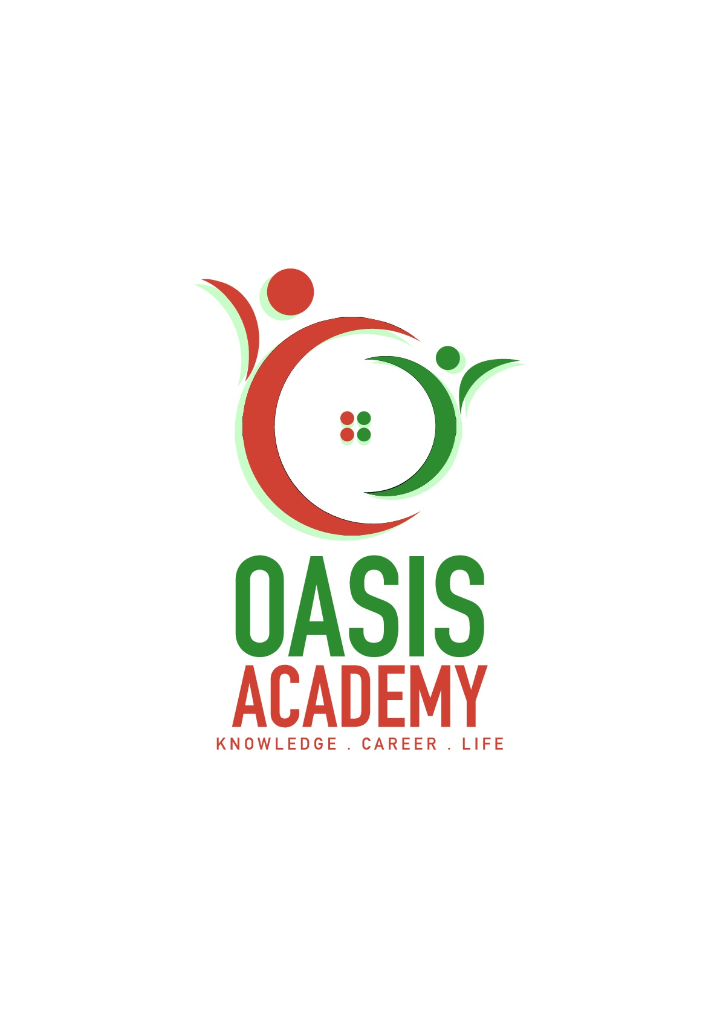

Name: Kong Loke Yee

Login ID: konglokeyee@oasis-portal.com

Course title: Tourism and Hospitality Materials

Subject Code: BHM04

Submitted date: 11 Sep 2017

**Table of Contents**

|  |  |  |
| --- | --- | --- |
| **No** | **Details** | **Page** |
| 1 | Executive Summary | 2 |
| 2 | Introduction | 3 |
| 3 | Assignment Question |  |
|  | Part 1 | 4-7 |
|  | Part 2 | 8-11 |
|  | Part 3 | 12-13 |
|  | Part 4 | 14-15 |
| 4 | Conclusion | 16 |
| 5 | References | 17 |
|  | Appendix | 18 |

**Executive Summary**

In this module, I learn about what is Tourism and Hospitality. There are many type of Tourism and many importance of Hospitality. Now, I also know lodging accommodation and the type of hotel accommodation. Last but not lease, I learned the significant of entainment.

**Introduction**

Tourism and hospitality is a relationship between guest and host. Hospitality is a place where tourist stay and the host must treat the guest with goodwill. There are different type of Tourism like leisure tourism, culture tourism and so many. Lodging accommodation is a sector of hospitality industry from luxury to the moderate hotel. Entertainment of travel is to let tourist fully enjoy their holidays.

**Question 1**

**Define the Tourism and Hospitality.  
Explain your understanding about Hospitality industry.**

Tourism is an activity of people travelling to another place outside of comfort zone for not more than a year. Tourism is important for many countries because it is one of the income generated based on the consumption of goods and services by tourists. The tourism system consists of 3 elements which are tourist, the geographical elements and the tourism industry. Type of tourist depends on their main activity such as holiday, business, adventure, health and so many.

Hospitality is a relationship between guest and host. Host means a person who invites guest to a social event and responsible for guest while there stay in their place. So, host supposed to treat every guest with goodwill including the reception and entertainment of guests.

Tourism and Hospitality consist of lodging travel and tourism recreation, amusements, attractions area, resorts, restaurant and food beverage service. This is the reason why Tourism and Hospitality become the largest employment rate in a country.   
What is the tourism product?

|  |  |
| --- | --- |
| The 6 A’s of tourism product | Example |
| Access (transportation) | Flight, travel bus |
| Accommodation (place to stay overnight) | Hotel, motel, flotel, inn, resort, services apartment |
| Attractions (natural or man-made) | Singapore’s Marina Bay, Singapore’s Sentosa, Malaysia’s A Famosa, Museum |
| Activities (festivals and events) | Halloween, Christmas, Chinese New Year |
| Amenities (essential facilities) | Swimming pool, gymnasium, spa, barbeque area |
| Ancillary Services (extra services) | Booking taxi for customer to airport |

Hospitality Industry is a field within service industry that includes lodging, event planning, theme parks, transportation. A hospitality unit such as restaurant hotel, amusement parks. There is a few industry considered Hospitality Industry: Accommodation, Restaurants and Bars, Travel and Tourism.

Example of Accommodation:

Serviced Apartment Hotel  
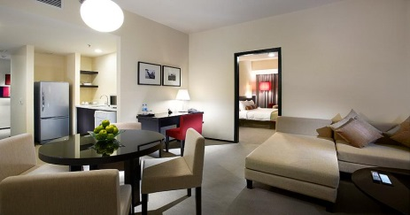 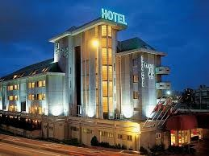

Flotel

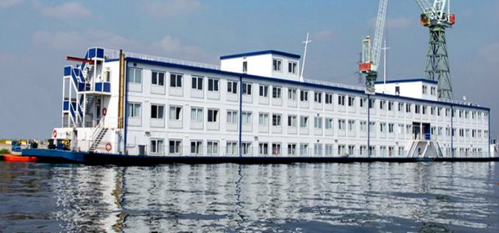 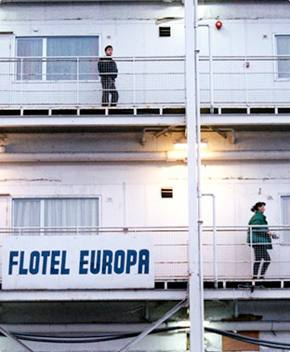

Motel Inns

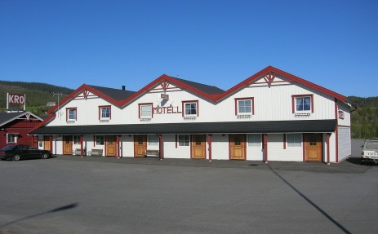 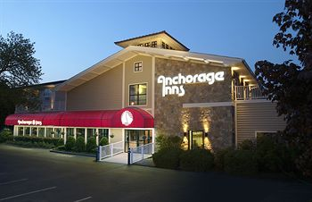

Resort

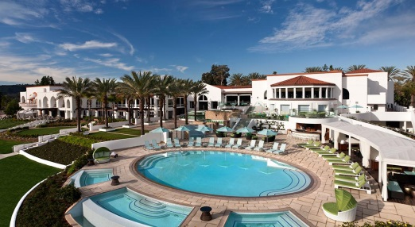

Example of Restaurants and Bars:

Night Club Pubs and Public Houses  
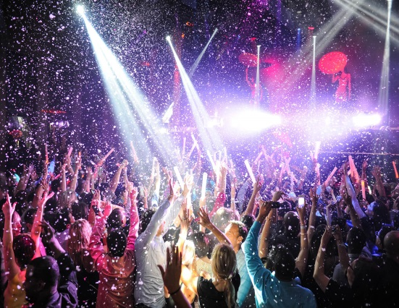 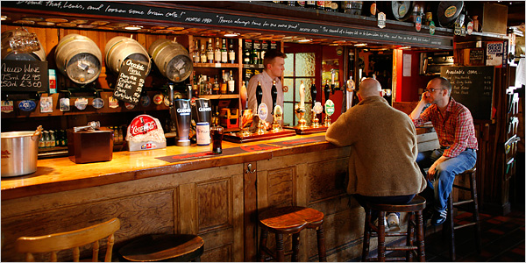

Restaurant Bar

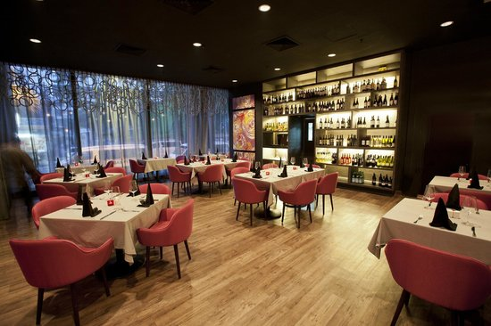 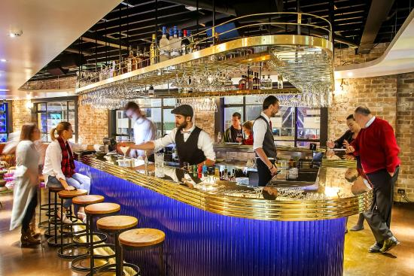

Example of Travel and Tourism:

Travel Agents

 

Tour Operators

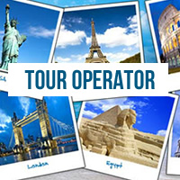 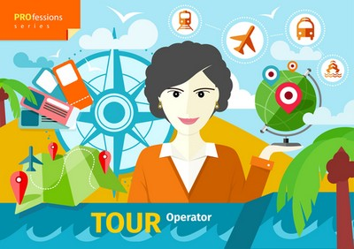

Leisure Centres

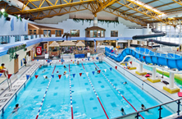 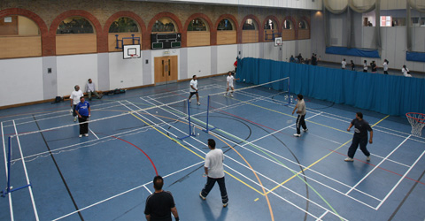

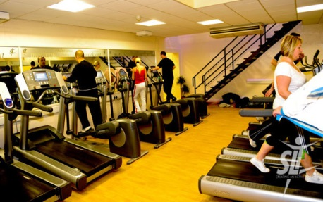 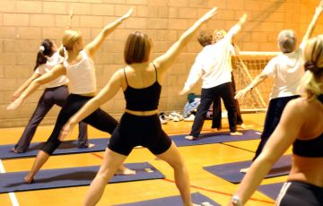

Leisure centre can be swimming pool, badminton court, gymnasium, yoga room and so on.

**Question 2**

**Brief on different type of Tourism categories. Define Tourism.**

1. Leisure Tourism

Tourist will travel for experience a new place, new climate, new culture and enjoy the beautiful scenery. Some tourist who always feeling stress and need a gateway to release their pressure, they prefer to stay in some quiet and relaxed destination such as hill resort, beach resort or island resort. For example, Genting Highland, Malaysia, Batam Island.

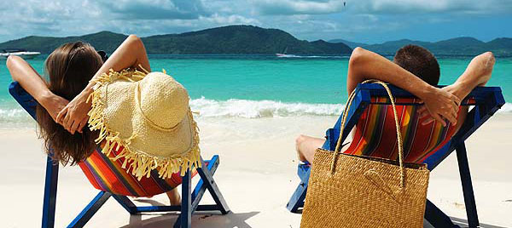

1. Culture Tourism

Culture Tourism is also called heritage tourism. Culture is the most important reasons that attracts tourist to a destination. Tourist are curious about culture.

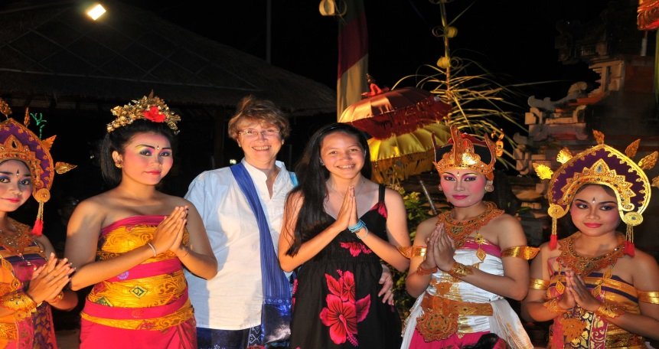

1. Religious Tourism

Religious Tourism is also called Pilgrimage Tourism or Spiritual tourism. It is a form of tourism, where people travel individually or in groups for pray. For example, Makkan.

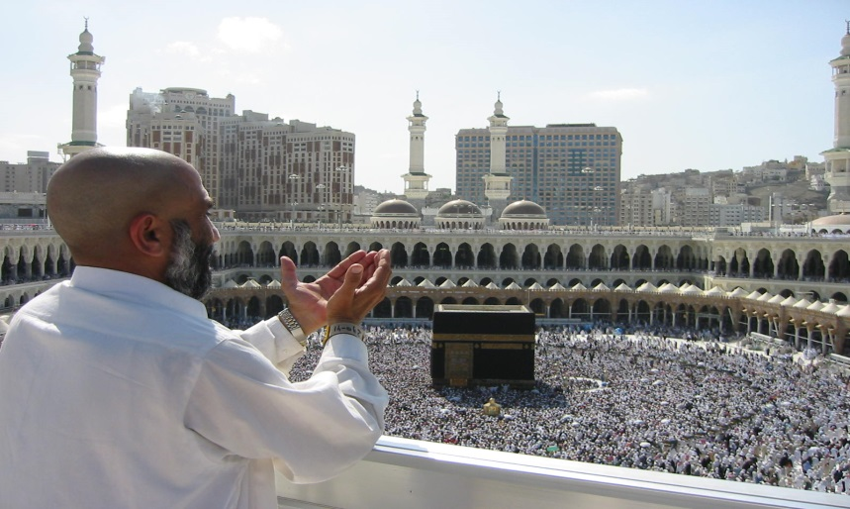

1. Family Tourism

Family Tourism is a family travel for visiting their friends and relatives or participating party and meeting.





1. Health Tourism

Health tourism is also called as Medical tourism. People travel for improve and rebuild their health. Nowadays, many people prefer going to other country for medical treatment because the facilities of medical is better than their own country.  
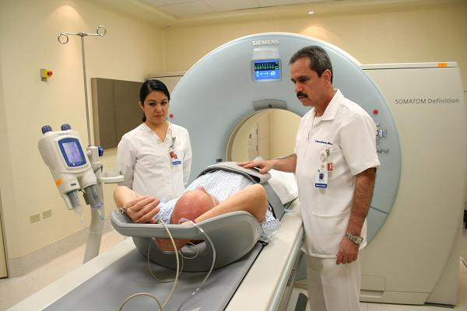  
Besides, many hospitals have specially designed packages including resorts facilities.

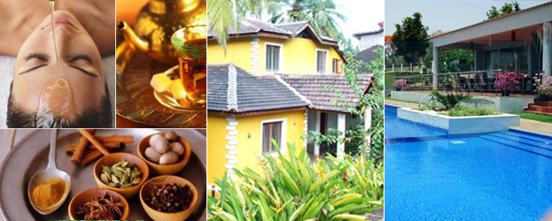

1. Sports Tourism

Sports Tourism refers to people travelling to participate in a sports event or visit a sport event like Olympic Games, FIFA World Cup.

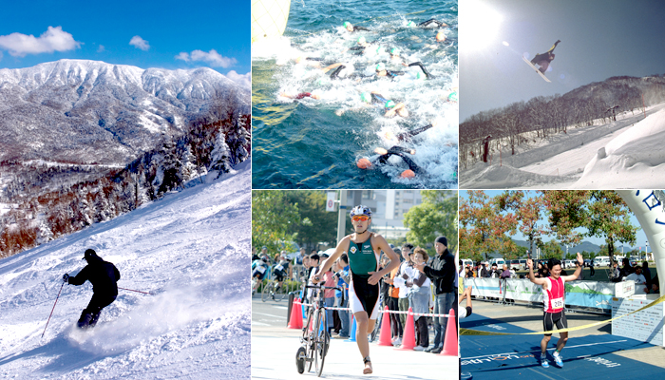

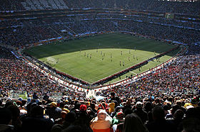

1. Educational Tourism

The main purpose of educational tourism is to learn about the culture of another country such as Student Exchange Programs and Study Tours. Through this program, student can grow their knowledge outside of their environment.

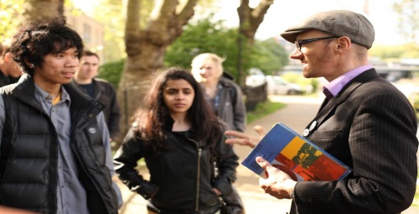

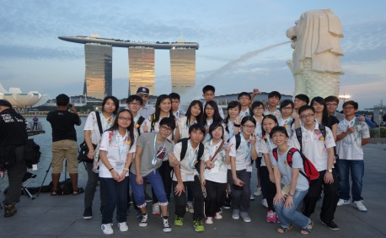

1. Business Tourism

The main motive of business traveler is to expand their business or maintain their current business level. They attend a business meeting, conferences, cnventions selling product and meeting their clients.

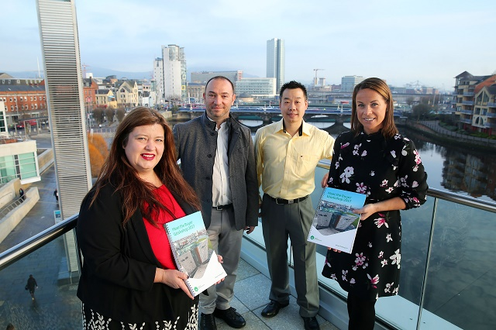

Tourism is an activity of people travelling to another place outside of comfort zone for not more than a year. Tourism is important for many countries because it is one of the income generated based on the consumption of goods and services by tourists. The tourism system consists of 3 elements which are tourist, the geographical elements and the tourism industry. Type of tourist depends on their main activity such as holiday, business, adventure, health and so many.

**Question 3**

**Describe the lodging accommodation and types of Hotel accommodation.**

Lodging Accommodation is a sector of hospitality industry from luxury to the moderate hotel. Other than that, accommodation is a broad sector of hospitality industry, bed and breakfast is a must and also include other facilities. So, customer service is very important in providing accommodation services for tourists.

For tourist, there are three things that they really need in their trip. The first and the most important thing is accommodation. They really need a comfortable shelter to rest in an unfamiliar city. Other two are Food and Transportation, if they have arranged for hotel and accommodation, they will automatically find this two.

Below are three main types of hotel and accommodation services:

Lodging

When people travel from one place to the other, they need a place to sleep. A shelter which will keep them safe from the atrocities of nature. This results in people booking lodges and rooms for their stay.

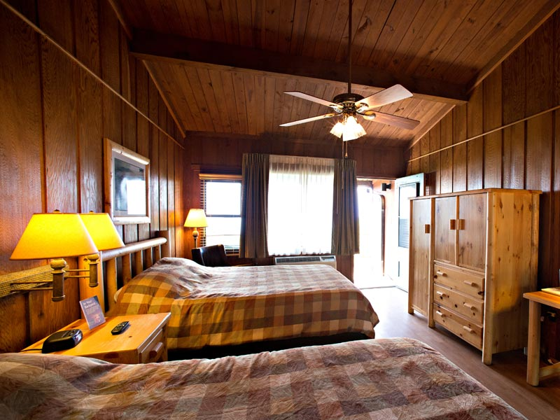

Suites

Apart from general lodges to stay, hotel sector offers luxury suites for the stay as well. Generally, suites are suitable for formal sorts of staying and are much expensive compared to regular room services.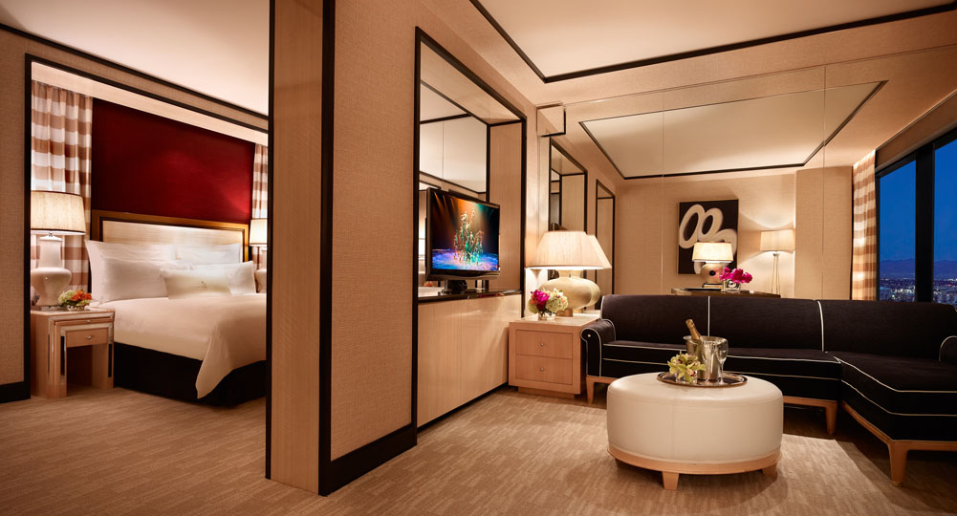

Resorts

The third type of accommodation which is popular among travellers are resorts. These bring you close to nature and give you a necessary break from your formal routines.

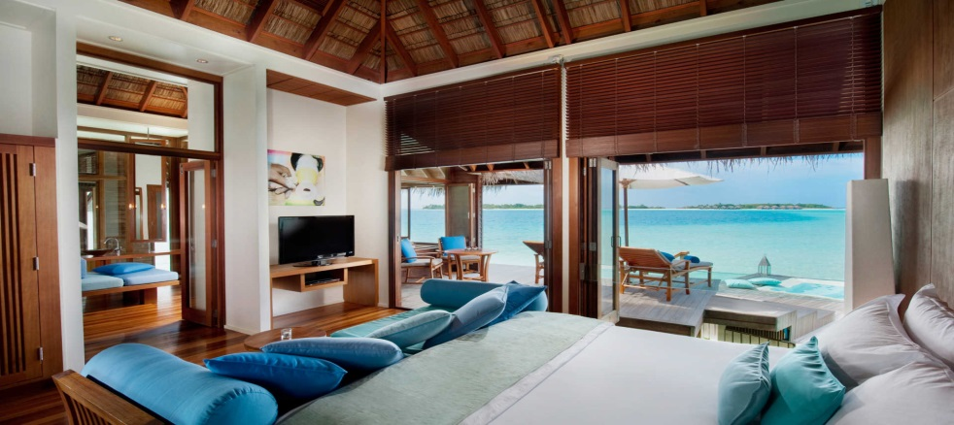

Below are Food and Transportation that tourist needed also when they are travelling.

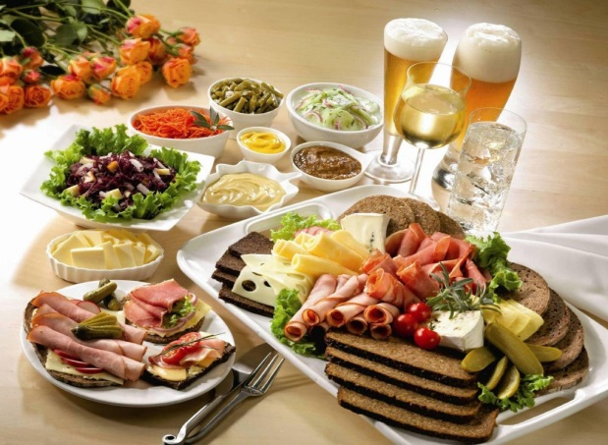 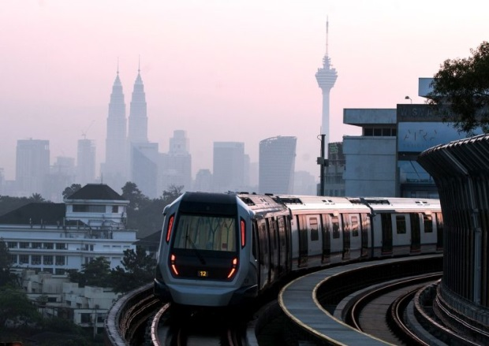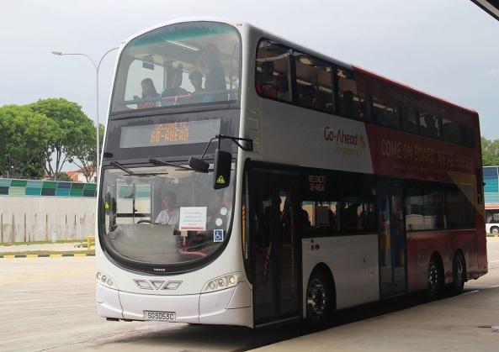 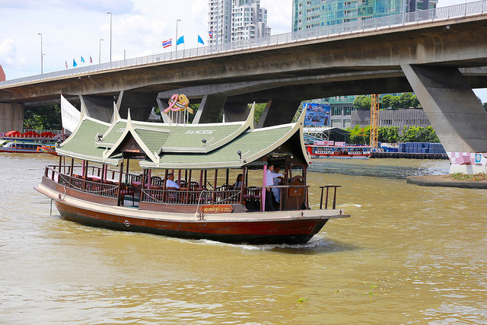

**Question 4**

**Explain the Significant of Entertainment in this industry**

Entertainment is also an important category in the hospitality industry. If your travel lack of fun and entertainment, then you may not be able to fully enjoy your time. So, in order to successfully run a hospitality business, it is vital to have as many recreational activities as possible.

Some of the activities that you can enhance your experience are:

Marinas

Marinas are one of the most popular places to go. You can get along with your friends on a private yacht where you can dance, play games, and enjoy the best of your life.

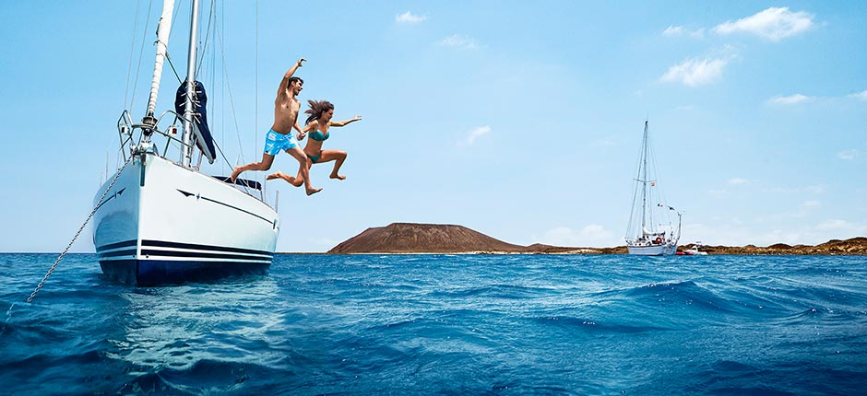

Sports and Gaming

Sports and gaming is a basic thing which people are looking for on their travel. For example, Casinos, swimming pools, and other similar activities.

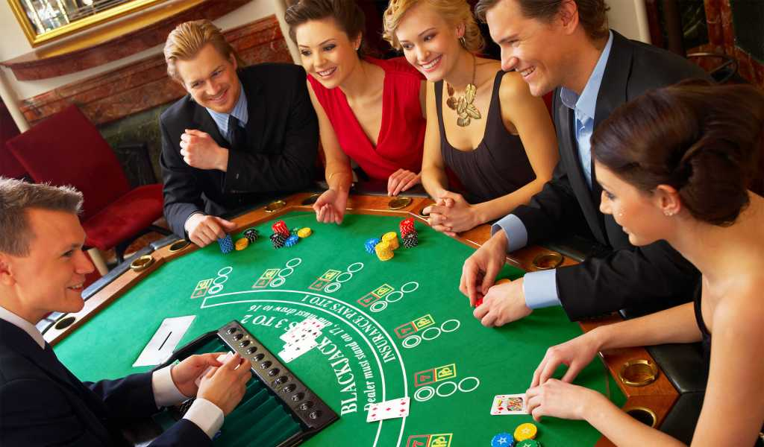 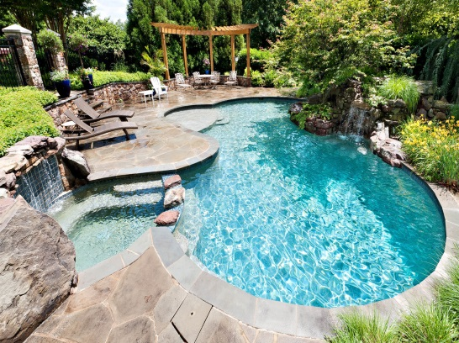

Cruise

Apart from marinas, cruise services are also becoming an important part of the hospitality industry. Now, people like to spend their days on luxury ships which sail across the blue oceans under the clear sky.

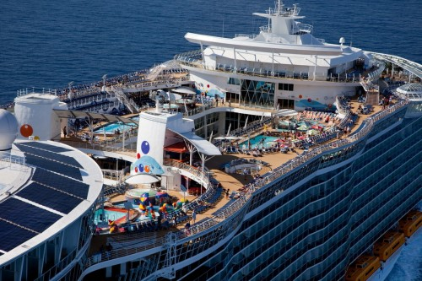

Nightclubs

Who doesn’t love to dance on their favorite song when on a break? We all do. This is why hotels have nightclubs services in them.

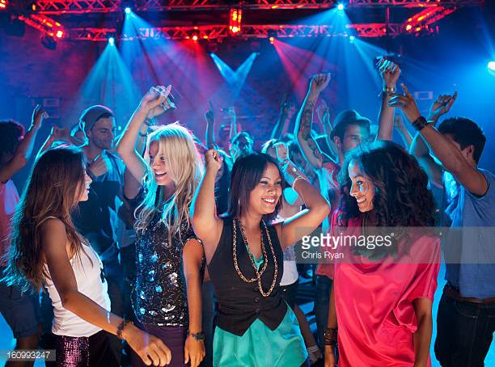

Bars

Sitting around a table and having a couple of drinks with your friends is always a refreshing experience.



**Conclusion**

Tourism and Hospitality consist of lodging travel and tourism recreation, amusements, attractions area, resorts, restaurant and food beverage service. Besides spending holiday, there are many purpose for people to travel to another country. Accommodation is a shelter for tourist to stay, is depends on the level of people and the purpose of travel. Then, a successful hospitality business must have their entertainment for their customer.

**References**

Online

1. <https://www.google.com.sg/search?q=leisure+tourism&source=lnms&tbm=isch&sa=X&ved=0ahUKEwjiyOSiwp3WAhUIto8KHYC2AwAQ_AUICigB&biw=1242&bih=535>
2. <https://www.google.com.sg/search?biw=1242&bih=535&tbm=isch&sa=1&q=culture+tourism&oq=culture+tourism&gs_l=psy-ab.3..0i19k1j0i7i5i30i19k1l3.31489.33985.0.34138.14.14.0.0.0.0.108.966.12j1.13.0....0...1.1.64.psy-ab..1.13.957...0j0i7i30i19k1j0i7i30k1j0i13k1.ImDa9SQmbcs#imgrc=_>
3. <https://www.google.com.sg/search?biw=1242&bih=535&tbm=isch&sa=1&q=religious+tourism&oq=religtourism&gs_l=psy-ab.1.1.0i19k1j0i7i30i19k1l3.113317.114090.0.116736.5.5.0.0.0.0.325.325.3-1.1.0....0...1.1.64.psy-ab..4.1.320.Fk3M9BSKl5I>
4. <https://www.google.com.sg/search?biw=1242&bih=535&tbm=isch&sa=1&q=family+tourism&oq=family+tourism&gs_l=psy-ab.3...13058.14229.0.14362.7.7.0.0.0.0.149.382.0j3.3.0....0...1.1.64.psy-ab..5.1.146...0i13k1.ToZTBkJDwJY>
5. <https://www.google.com.sg/search?biw=1242&bih=535&tbm=isch&sa=1&q=health+tourism&oq=heatourism&gs_l=psy-ab.3.0.0i7i30k1l4.15634.18864.0.21245.11.10.0.0.0.0.454.955.1j3j4-1.5.0....0...1.1.64.psy-ab..6.5.945...0i19k1j0i13k1.myP-HCOW_qE>
6. <https://www.google.com.sg/search?biw=1242&bih=535&tbm=isch&sa=1&q=sport+tourism&oq=sport+tourism&gs_l=psy-ab.3..0i19k1l2j0i30i19k1j0i7i5i30i19k1.83.83.0.968.1.1.0.0.0.0.467.467.4-1.1.0....0...1.1.64.psy-ab..0.1.465.2l6EIJfzT-4>
7. <https://www.google.com.sg/search?biw=1242&bih=535&tbm=isch&sa=1&q=educational+tourism&oq=educa+tourism&gs_l=psy-ab.1.0.0i7i30k1l4.10247.13755.0.15669.7.7.0.0.0.0.791.1157.5j6-1.6.0....0...1.1.64.psy-ab..1.6.1152...0j0i8i30k1j0i12i24k1j0i19k1.zLnlR6cKxhU>
8. <https://www.google.com.sg/search?biw=1242&bih=535&tbm=isch&sa=1&q=business+tourism&oq=business+tourism&gs_l=psy-ab.3...1035.1035.0.1073.1.1.0.0.0.0.0.0..0.0....0...1.1.64.psy-ab..1.0.0.xrNvDLLdicE>

**Appendix**

(Appendix is for more detailed information on a subject that is too long to explain in 1 page)

Example:

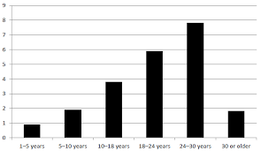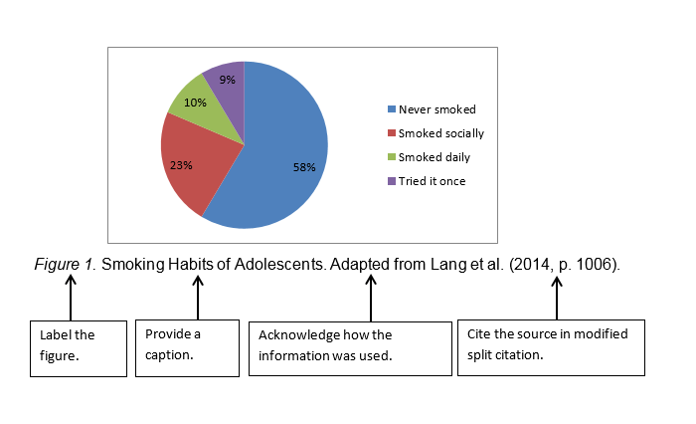

THE END